 | POLICY | HEALTH AND SAFETY
 | DATE | 04 JANUARY 2015
 | VERSION | ISSUE 0.2
 | REVIEW | BY DECEMBER 15

CONTEXT
Seven Questions Consulting Limited has fewer than five permanent employees and is therefore exempt from the requirement to produce a detailed written Health & Safety policy. However, the principles under which the company operates are articulate din the policy statement below.
POLICY STATEMENT
Seven Questions Consulting Limited is committed to providing a safe working environment for its employees and associates.

The key points of its strategy to achieve this are:

- Understand and adhere to client Health and Safety policies and procedures
- Maintain an accident register
- Recognise that RTA are the highest risk to consultants and therefore maximize the use of public transport, minimise journeys, adopt defensive driving techniques and safe driving principles at all times.
- Ensure all employees have regular health and eye check ups.

REVIEW

The effectiveness of this policy and associated arrangements will be reviewed bi-annually under the direct supervision of the Managing Director.

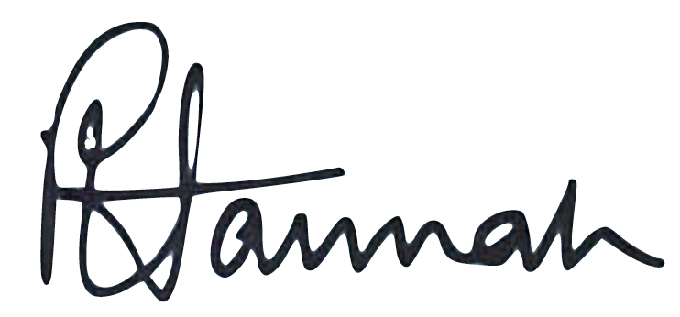
P W HANNAH
Director
Seven Questions Consulting Limited

