Environmental Policy

Director with responsibility: Mr Nicholas Phillips

Role: To ensure that wherever practical Funnells limited will work to strong environmental practices and will review its policy every 6 months.

Mission Statement

*Funnells will strive to limit its impact on the environment through implementing strong internal practices.*

Our environmental practices are to include:

* Sourcing environmentally friendly products
* Limiting the use of paper within the office through electronic storage, duplex printing and education of staff in good environmental processes
* Printer cartridges will be recycled through the Samsung STAR program
* 85% of all waste will be recycled with the use of separate bins with clear bags
* In all of our products and services we will seek to incorporate environmental best practise
* All staff will ensure that energy consumption is minimised by turning off lights and equipment where practical and not leaving equipment on standby overnight.
* We will use only biodegradable or plant-based compostable foodservice packaging.

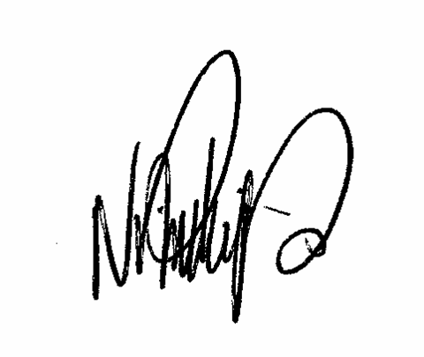

Date: March 2021 Signed

Nicholas Phillips

Director