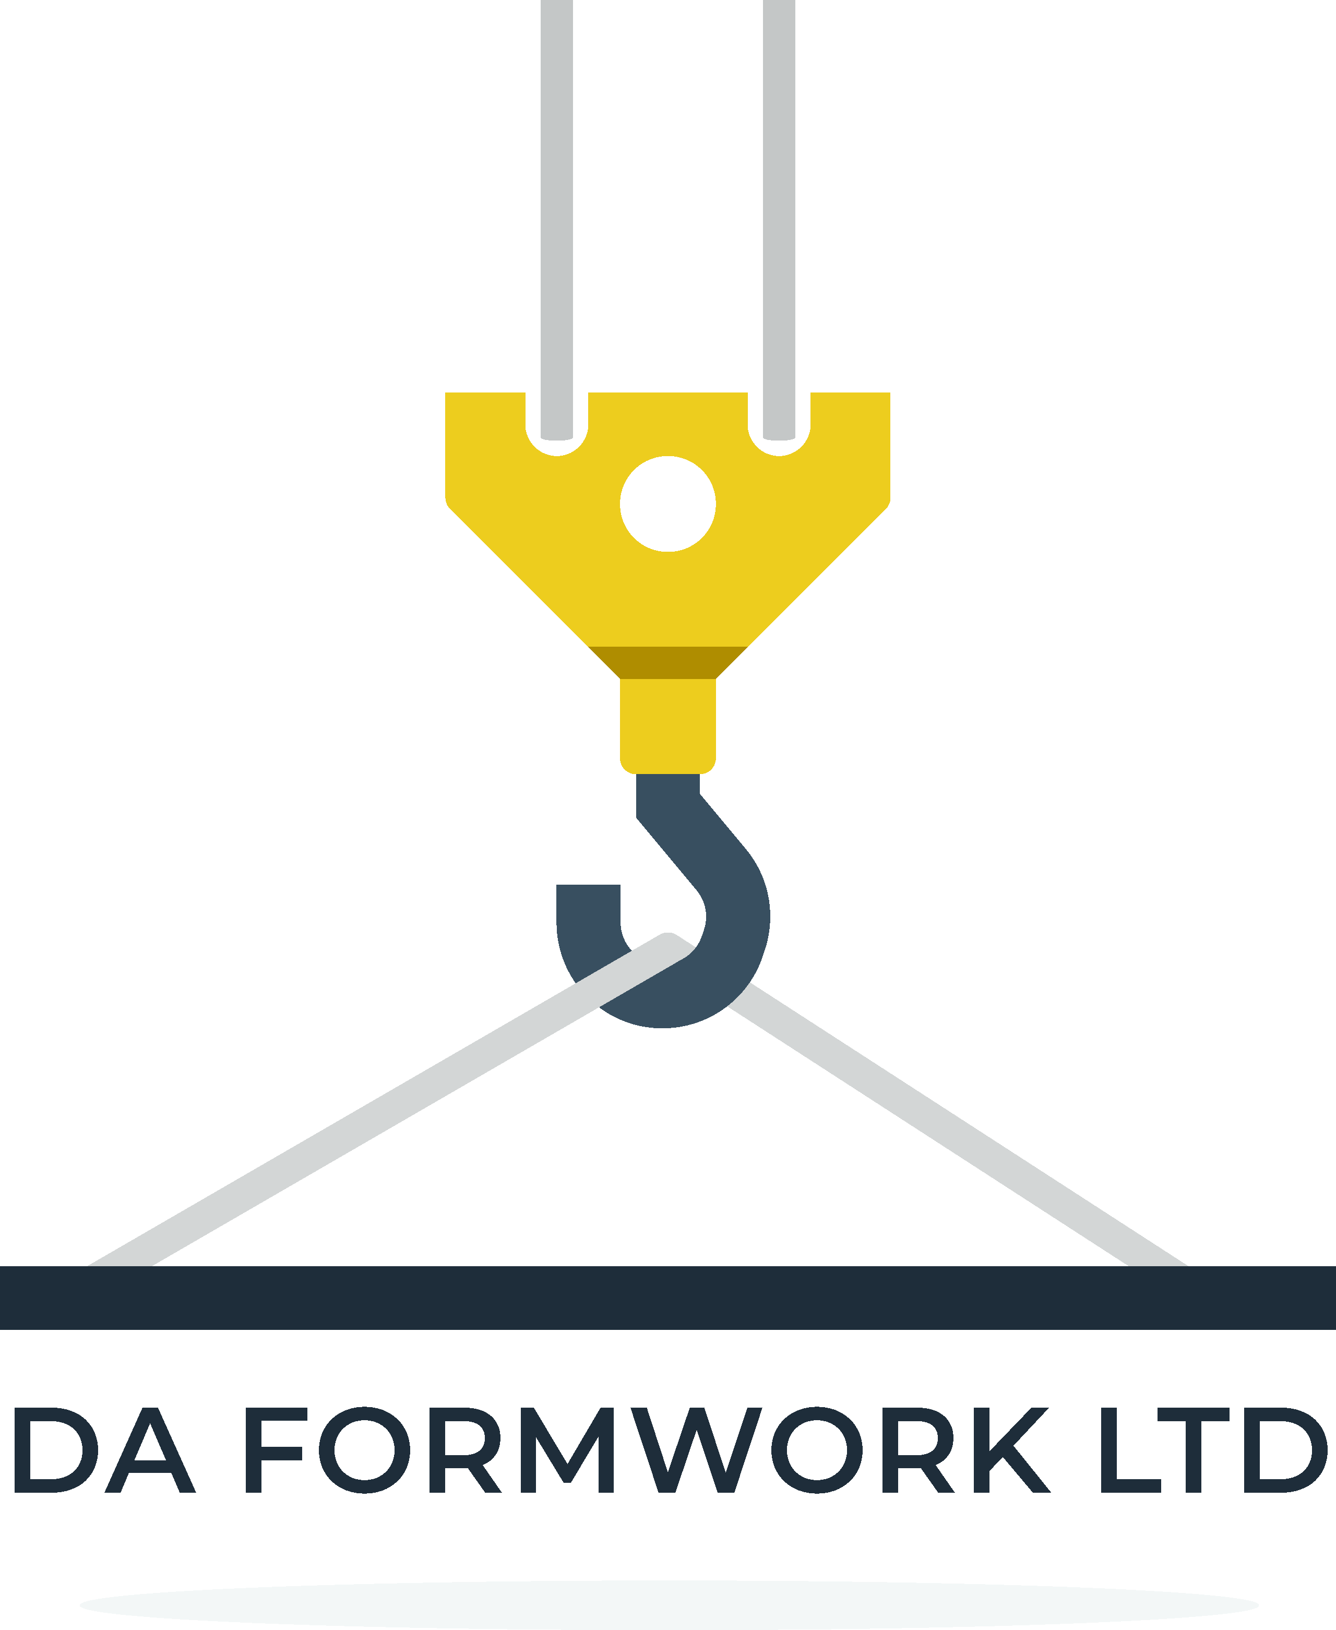

**Health and Safety Management Action Plan**

**This statement sets out D A FORMWORK LTD commitment for Health and Safety at work**

**Part A.** What we’re trying to do

**We aim to:**

• Avoid accidents and damage to people’s health by not cutting corners on health and safety issues.

• Ensure that we pay as much attention to health and safety as any other key business objective.

• Always follow safe systems of work.

• Avoid buying in unsafe products.

• Work to legal requirements as a minimum standard to be achieved.

• Always insist on high standards of health and safety when dealing with others.

• Strive for continuous improvement in health and safety performance.

**How we’re going to do it:**

**We will always:**

• Make sure we consider health and safety whenever we plan anything (however small).

• Identify hazards, assess risks to see whether our control measures are adequate or need to be improved and (see below).

• Set ourselves measurable health and safety standards and targets with dates for implementation.

• Monitor how well we are achieving them (for example, through inspection) and record results.

• Report and record all accidents and incidents and investigate them to see why we have not been able to prevent them.

Consult everyone to get their views about possible health and safety problems and solutions.

• Communicate all necessary health and safety information.

• Provide necessary training for everyone so they can meet their health and safety responsibilities.

• Get advice from outside competent specialists whenever we need it.

• Meet basic workplace welfare requirements, have appropriate first aid and employers liability insurance.

• Make time every twelve months to see how we’re doing, record our findings, and, where necessary make improvement.

**Who is responsible for what?**

• Daniel Allen, as overall managing director, has overall responsibility for health and safety in the company.

• Andrew Allen as supervisor must make sure safe systems of work are always followed and carry out regular monitoring.

• Every member of staff must co-operate in following safe procedures, report problems and make suggestions for improvements.

• Our contractors and suppliers must provide us with all necessary safe information and co-operate with our health and safety requirements.

**PART B.**

**Record of Risk Assessments**

**HAZARDS**

What could cause harm?

Machinery?

Chemicals?

Manual Handling?

Electricity etc?

**RISKS**

What could happen?

How bad could it be?

How likely is it?

Who could be affected?

What is the risk level? - High, Medium or Low?

**CONTROL MEASURES**

What do we need to do to prevent harm?

Is it adequate?

Do we need to do more?

If so, by when?