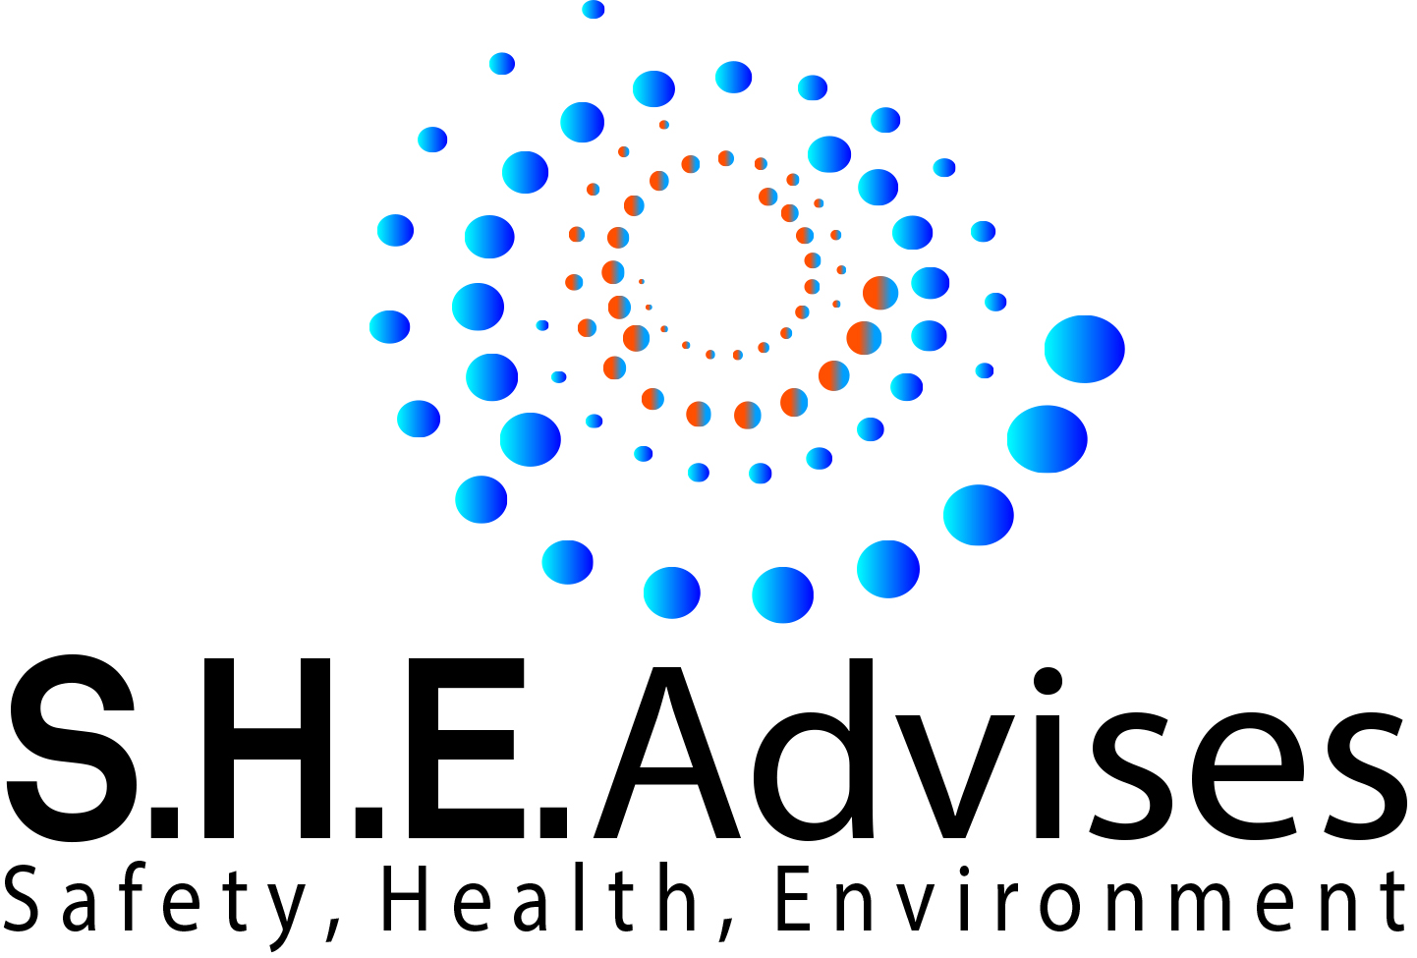

Quality Assurance Policy

Quality Statement
SHE Advises Ltd is committed to providing high quality services and deliverables. We will apply effective project management and provide outstanding customer service following Quality Management Principles.
Key aspects of SHE Advises Ltd include:
Health and Safety consultancy offering advice and assistance
Health and Safety accredited and bespoke training
Regular Peer assessment of delivery standards
Administration of company and client resource and documentation
Quality Management
SHE Advises Ltd operates a quality management system (QMS) to ensure that we deliver consistent high quality services, and focus on continual improvement. In respect of training QMS is driven by the licensed bodies that accredit and invigilate SHE Advises Ltd. Resource and deliverables will be designed and delivered to meet and where appropriate exceed the customer expectations. This includes ensuring that we meet and exceed the requirements of the Health and Safety at Work etc. Act 1974 and the relevant industry-specific regulations and best practice.
This document is available on our company shared drive and is made available to all trainers who deliver on our behalf. Changes to the QA policy will be made where approved by a Director and only the current version available on our shared drive accessible by tutors and staff.
N Wales-Dixon Director

Signed

Dated

