**Client:** Team Van Oord for Environment Agency

**Contact:** Terry Gretton

**Tel: 01273 492212**

**E-mail**: terry.gretton@mackley.co.uk

**Value:** £260,000

**Date of Works:** March 2012 – September 2013

**Medmerry Managed Realignment Scheme: Watervole Habitat Creation Works:**

Salix were appointed as a specialist contractor to undertake 7km of highly sensitive Watervole habitat creation works to create sufficient habitat to allow habitat to be lost as part of a coastal breach. Salix provided detailed proposals and mapping of translocation donor and receptor sites. Works included sensitive mechanical and manual translocation works for 3km of channel with donor material sensitively removed from within existing Watervole habitats. Salix provided an ecological watch over these works and strong design input relating to the best techniques used for specific site conditions and within budget. Additional works include maximising the rapid establishment of suitable Watervole habitat within 4km of new watercourses using various vegetation establishment methods. Several vegetation communities were identified and specific translocation method statements developed for each.

Access was achieved before any of the main haul roads were installed using tractors and trailers and in house tracked dumpers.

Additional works included grass and wildflower seeding of over 40,000m2 of new channels and reedbed embankments.

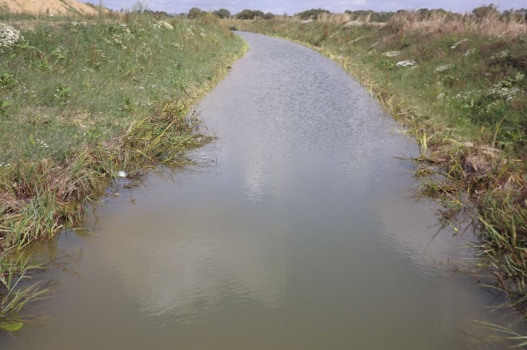 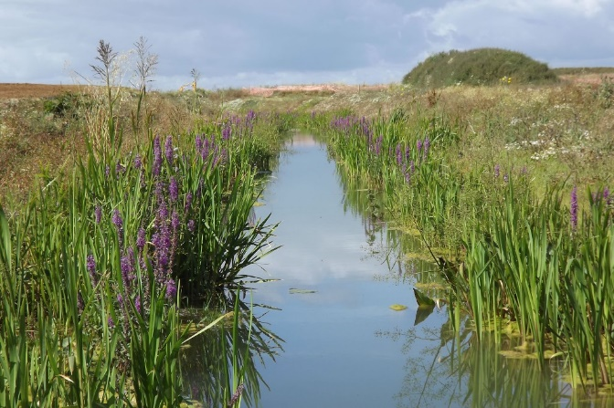

Coir Pallets after installation Coir Pallets in August after 14 months

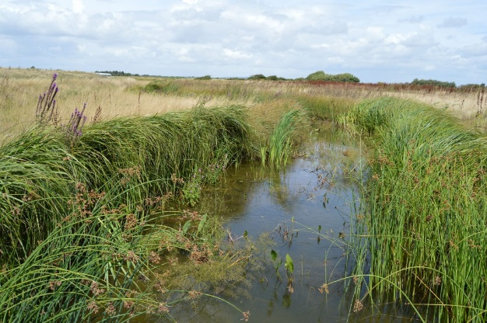

Coir Pallets after 18 months, creating mature water vole habitat