**Name of customer organisation:** London Wildlife Trust  
**Point of contact in the organisation:** David Mooney  
**Position in the organisation:** Project Manager  
**E-mail address:** dmooney@wildlondon.org.uk  
**Contract Start date:** February 2015  
**Contract completion date:** June 2015  
**Estimated contract value:** £105,000.00

**Description of contract:** Woodberry Wetlands Reedbed Creation – Design and Build

Salix successfully completed a large project for the London Wildlife Trust’s scheme - Woodberry Wetlands. The work involved de-silting an unused reservoir and using the dredgings to create 13,000 square metres of new reed bed. To achieve this approximately 8000m3 silt was placed behind Nicospan and [Brushwood Fascine](http://www.salixrw.com/product/brushwood-faggots-fascines/) revetments by mechanical excavation and pump dredging to create a series of new islands and ponds, connected by channels of different depths. A large quantity of existing reeds were transplanted from existing reedbeds to the edge of the reservoir into the new reedbed areas where they will spread alongside fresh stock grown by Salix.

Both the dredging work and the new reed beds will help improve water quality and more than double the local wildlife habitat. As well as creating valuable new wetland habitats, the project also involved working with local volunteers to plant the native wetland and wildflower plants grown in house by Salix.

Local and national press/media took a keen interest in Salix’s role during this project since this site had previously been closed to the public since its construction in 1833. The media coverage was about bringing wildlife back to the heart of a City and encouraging the public to enjoy the reservoir once again. The scheme was officially opened by Sir David Attenborough

This job came in on budget and to the set timescale.

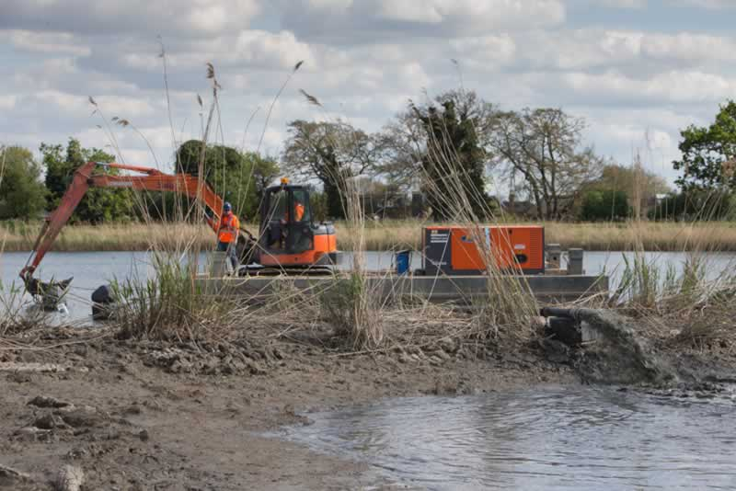 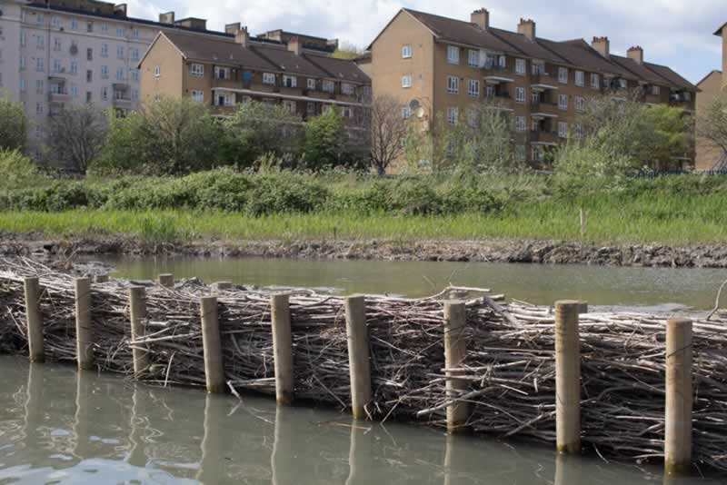

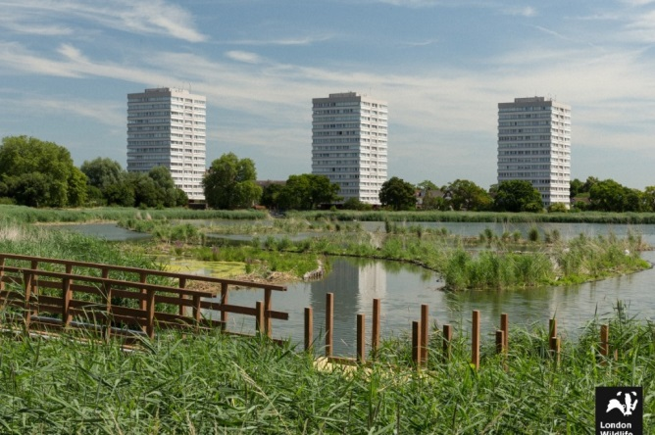

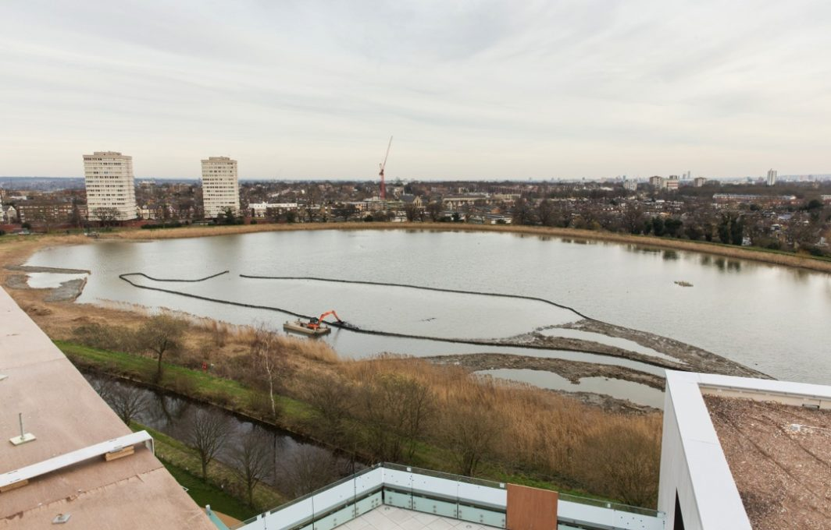

Wetlands during construction during localised channel dredging – main infill by pump dredging

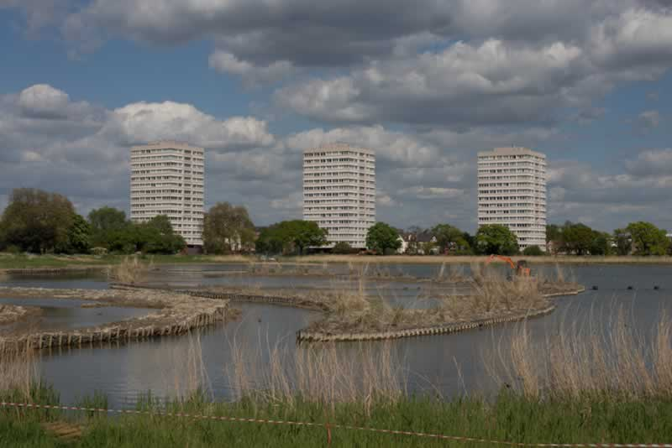

Project during reed turf translocation

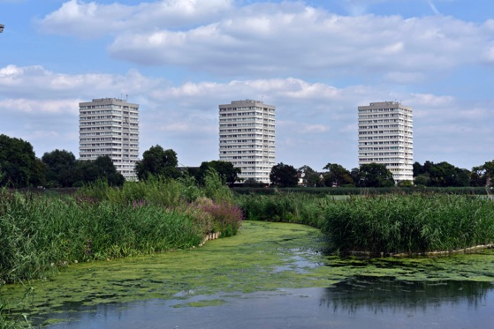

Translocated reeds after 2 seasons