**Client:** Aberdeen City Council

**Contact:** Ann-Marie Gauld

**Tel: 01224 522768**

**E-mail:** AMGauld@aberdeencitycouncil.gov.uk

**Value:** £284,000

**Date of Works:** March 14 – May 14

**East Tullos Burn Restoration and Wetland Creation**

We have constructed over 100 river restoration and enhancement projects throughout the UK over the last 11 years.

Salix recently delivered a river restoration scheme at East Tullos Burn, Aberdeen. The scheme involved the use of low ground pressure access machines to access and undertake the works. Works included temporary works including a channel diversion and sediment control works. The permanent works included the creation of an on line wetland (1 acre) to provide a water quality enhancement to the channel which struggles with excessive suspended solid levels and hydrocarbon release in high flows. Six offline wetlands and backwaters were also created and these were linked by a series of swales, again designed to increase water quality and to store an element of peak flood flows. Over 600 metres of channel was restored from a previous trapezoidal and straight channel to a meandering channel. Channel design (sizing and shape) and construction ensured that a Q95 base flow maintained a good fish passage. Rock ramp constructed as part of design as outflow structure to online treatment pond.  Design to aerate flow.

In total 6000m3 of earth was moved in a short (4 week period) time scale and the whole project was completed in just 8 weeks, including 800m of new access paths and 20,000m2 of wildflower seeding, with the additional planting of 180,000 native wetland and wildflower plants.

This project has won[two awards, a Highly Commended in the Sustainable Development category of the RSPB Nature of Scotland Awards in Edinburgh and came top in the Herald Society Awards in the Environmental Initiative of the Year category.](http://www.aberdeencity.gov.uk/planning_environment/planning/environment/txt_wac_east_tullos_burn.asp)

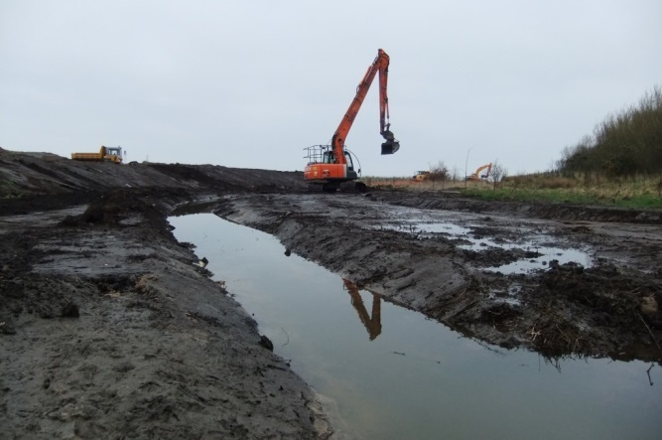 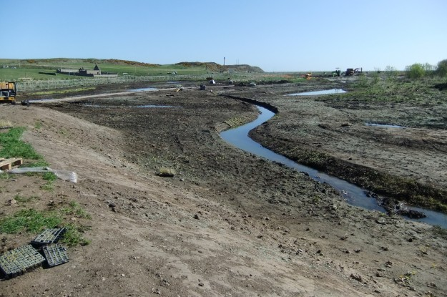

Re-profiling the stream at East Tullos

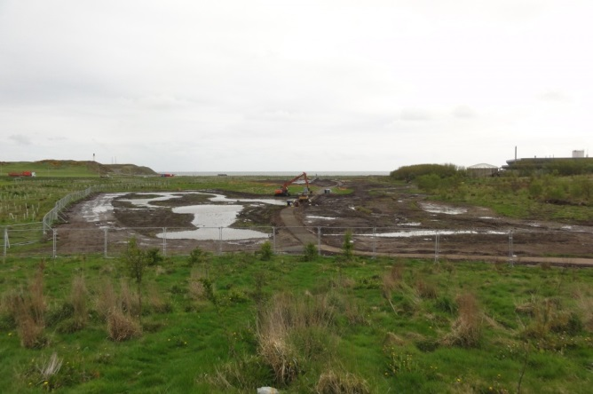 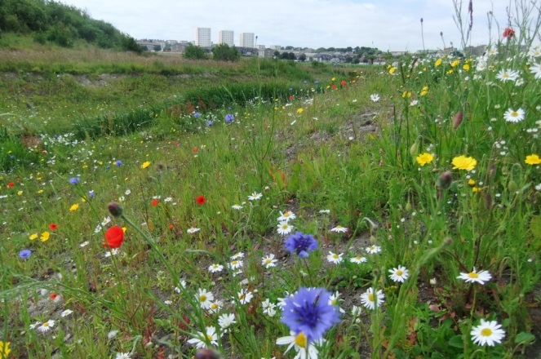Wetland bed in creation Flower meadow

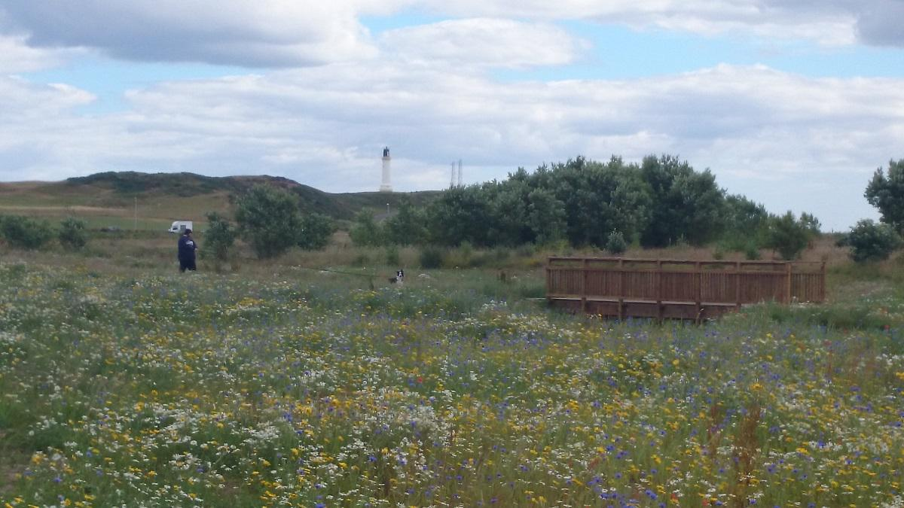

Footbridge