The Taste of Suffolk
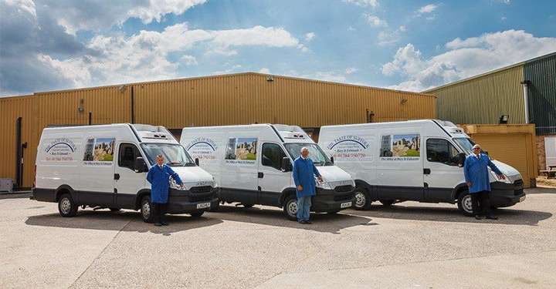
December 2021 | Health & Safety Policy and Arrangements

The Taste of Suffolk
Health & Safety Policy and Arrangements

Contents
- Policy Statement
- Risk Assessments
Access & Egress
Accident and emergency procedures
Agency workers
Asbestos
Butchery –use of knives
Compressors
Contractors
Cookers & Steamers
COSHH
Disability
Drivers/transport away from site
DSE
Electrical safety
Epidemic or Pandemic
Factory General
Fire
Food contamination
Fork Lift
Gases
Icy Conditions & Winter Weather
Information Security
Loading and moving racks/trolleys
Loading and unloading vehicles
Lone working
Manual Handling
Office equipment
Pregnant workers
Visitors
Waste management
• Waste from processing area
• Waste from high care
Wood smoker
Working at heights
Working in a cold environment
Young person

Health and safety policy

Health and safety policy statement

The Taste of Suffolk has established this Health and Safety Policy to ensure the Health, Safety and Welfare at work of all employees and others who may be affected by its activities. This policy will be implemented in all premises owned or controlled by the Company, and is applicable to all staff and visitors at our site. This policy also applies to our staff working away from company sites.

In pursuance of this policy, the Company will take action to:

- Identify, assess, and manage the health and safety risks arising from our work activities;

- Consult with our employees and seek their cooperation on matters affecting their health and safety;

- Provide and maintain safe plant and equipment;

- Ensure safe handling and use of substances;

- Provide information, instruction and supervision for employees;

- Ensure all employees are competent to do their tasks and to give them adequate training;

- Prevent accidents and cases of work related ill health, so far as is reasonably practicable; maintain safe and healthy working conditions;

- Oversee the implementation and function of the safety management system, and monitor and review this policy on an annual basis.

- Take disciplinary action for any breach of Company safety law

……………………………………..
Signed by
[Managing Director/ Senior Partner/ Owner]

Responsibilities

- Overall and final responsibility for health and safety rests with Christopher Simons Managing Director
- Day to day responsibility for the management of health and safety at senior level rests with Tracey Ferencz

- Day to day responsibility for ensuring that this policy is put into practice, and for advice to staff and managers is delegated to Graham Simons as Competent Person. To ensure health and safety standards are maintained/improved, those listed below have responsibility in the following areas:

Name | Responsibility
Bacon/Ham | Tony Thrower
Sausage | Sharon Plume
Front Office | Graham Simons

Line Management responsibility

All line managers and supervisors must ensure that this policy is followed, and that staff are managed and supervised in accordance with it. Breaches of Company safety rules and procedures will be subject to disciplinary action.

- All employees are required to:

- co-operate with managers and supervisors on health and safety matters;
- not interfere with anything provided to safeguard their health and safety;
- take reasonable care of their own health and safety
- take reasonable care for the health and safety of others such as visitors
- report all health and safety concerns to an appropriate person (as detailed in this policy document)

Health and safety risks arising from work activities

- Risk assessments will be undertaken by Graham Simons

- Action required to remove/control risks by management will be approved by Graham Simons

- Graham Simons will check that the implemented actions have removed/reduced the risks.

- Assessments will be reviewed annually or when the work activity changes, whichever is the soonest.

Consultation with employees

- Employee representatives are Tony Thrower and Sharon Plume

Safe plant and equipment

- Christopher Simons will check that new plant and equipment meets health and safety standards before it is purchased.

- Tony Thrower will be responsible for identifying all equipment/plant needing maintenance.

- Tony Thrower will be responsible for ensuring effective maintenance procedures are drawn up.

- Tony Thrower will be responsible for ensuring that all identified maintenance is implemented.

- Any problems found with plant/equipment should be reported to Tony Thrower

Safe handling and use of substances

- Quality Manager will be responsible for identifying all substances which need a COSHH assessment.
- Quality Manager will be responsible for ensuring that all environmental issues are dealt with as part of this policy

- Quality Manager will be responsible for undertaking COSHH assessments.

- Graham Simons will be responsible for ensuring that all actions identified in the assessments are implemented.

- Quality Manager will be responsible for ensuring that all relevant employees are informed about COSHH assessments.

- Donna Ah-Choon will check that new substances can be used safely before they are purchased.

- Assessments will be reviewed annually or when the work activity changes, whichever is the sooner.

Information, instruction and supervision

- The Health and Safety Law poster is displayed at corridor opposite clocking in machine

- Health and safety advice is available from Graham Simons

- Risk assessments regarding the supervision of young workers/trainees will be arranged/undertaken/monitored by Graham Simons

- Graham Simons is responsible for ensuring that employees working at locations under the control of other employers are given relevant health and safety information.

Competency for tasks and training

- Induction training will be provided for all employees by QA Manager

- Job specific training will be provided by section supervisors

- Specific jobs requiring special training are butchery and food production

- Training records are kept by QA Manager

- Training will be identified, arranged and monitored by Quality Manager

Epidemic or Pandemic (inc Covid 19)

- A detailed risk assessment will be in place
- Covid discussions added as an agenda item to regular weekly Management/Supervisor meetings
- A separate circular on action required in the event of an outbreak will be retained in the staff room and master H&S Folder
- In the event of an incident actions will be overseen by the most senior Manager/Supervisor on site at the time of the incident

Accidents, first aid and work-related health

- Health surveillance is required for employees doing the following jobs:
- Driving, manual handling, computer screen/keyboard usage

- Health surveillance will be arranged by QA Manager

- Health surveillance records will be kept by QA Manager

- The first aid boxes are kept at Bacon/Ham production, Sausage production, Staff room

- The appointed first aiders are Gary Debenham, Odeta Ivoskaite and Andrew Filby

- All accidents and cases of work related ill health are to be recorded in the accident book. The book is kept in the QA managers office

- Graham Simons is responsible for reporting accidents, diseases and dangerous occurrences to the enforcing authority.

Personal Protective Equipment

Personal protective equipment will be provided to all staff free of charge. Such equipment must only be used in accordance with manufacturer’s guidance and Company risk assessment. Failure to wear appropriate equipment is dangerous and will lead to disciplinary action.

Monitoring

- To check working conditions and ensure safe working practices are being followed we will carry out regular inspections

- Graham Simons is responsible for investigating accidents.

- Graham Simons is responsible for investigating work-related causes of sickness absence.

- The Production Manager is responsible for acting on investigation findings to prevent a recurrence.

Emergency procedures – fire and evacuation

- Graham Simons is responsible for ensuring the fire risk assessment is undertaken and implemented.

- Escape routes and emergency lighting are checked every month

- Fire extinguishers are maintained by an external contractor

- Fire Alarms are tested weekly by Graham Simons

- Emergency evacuation will be tested Annually

