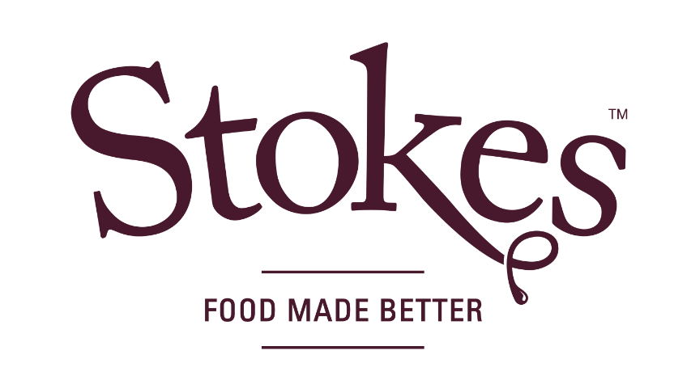

May 2021

We are delighted to announce that we have been awarded a gold accreditation from the Suffolk Carbon Charter as part of our commitment to become carbon neutral by the end of the year.

To achieve this, we have taken several measures such as switching to a 100% renewable energy supplier, transitioning over half of our vehicles to be electric, installing electric car chargers for staff and visitors, sourcing oil, which is carbon offset, and working with the World Land Trust to offset any additional emissions.

As a family business with a caring heart, we have taken steps in recent years to reduce our environmental impact such as our commitment to work towards zero to landfill and making our squeezy bottles not only 100% recyclable but also made from 100% recycled materials. Our founder Rick is passionate about the environment undertaking an extensive programme of tree planting and continuing to give a loving home to many rescued and re-homed animals right here at Stokes. His vision to create a greener, low carbon operation has been an inspiration to us all.

We are proud of our recent achievements and continue to take our responsibility to the environment very seriously at Stokes, always striving to improve our ways of working.

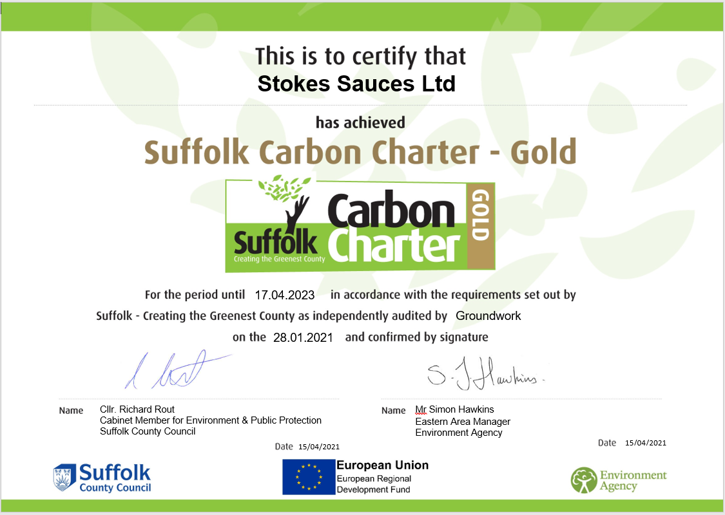
Learn more here: https://www.stokessauces.co.uk/environment-and-community/

