**Quality Policy Statement**

The company recognises that the disciplines of quality, health & safety and environmental management are an integral part of its management function.

The Directors consider these as a primary responsibility and to be the key to good business practice.

We will:

* Comply with all applicable laws and regulations
* Follow a concept of continual improvements and make best use of our resources by setting and reviewing objectives to achieve the improvements in Quality.
* Take due care to ensure that our work activities are safe for our employees, suppliers, visitors and others who come into contact with our environment.
* Work closely with our customers and suppliers to establish the highest quality standards.
* Comply with our industry codes of practice.
* Conduct our business in a fair and ethical manner.
* Train our staff in the needs and responsibilities of our Quality Management Systems.
* Be aware of our environmental responsibilities when carrying out our work processes.
* Review and revise our policy at planned intervals to comply with the requirements of the standard.
* We are committed to carrying out the requirements of our Management System which meets the needs of our customers.

Signed

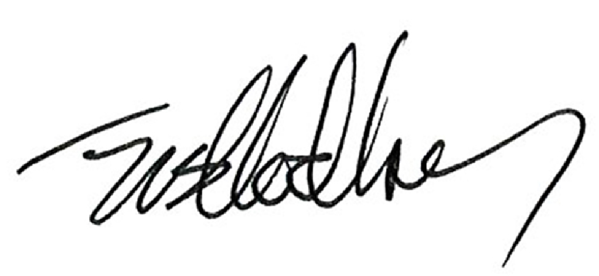

Group Managing Director Date:24/08/2021