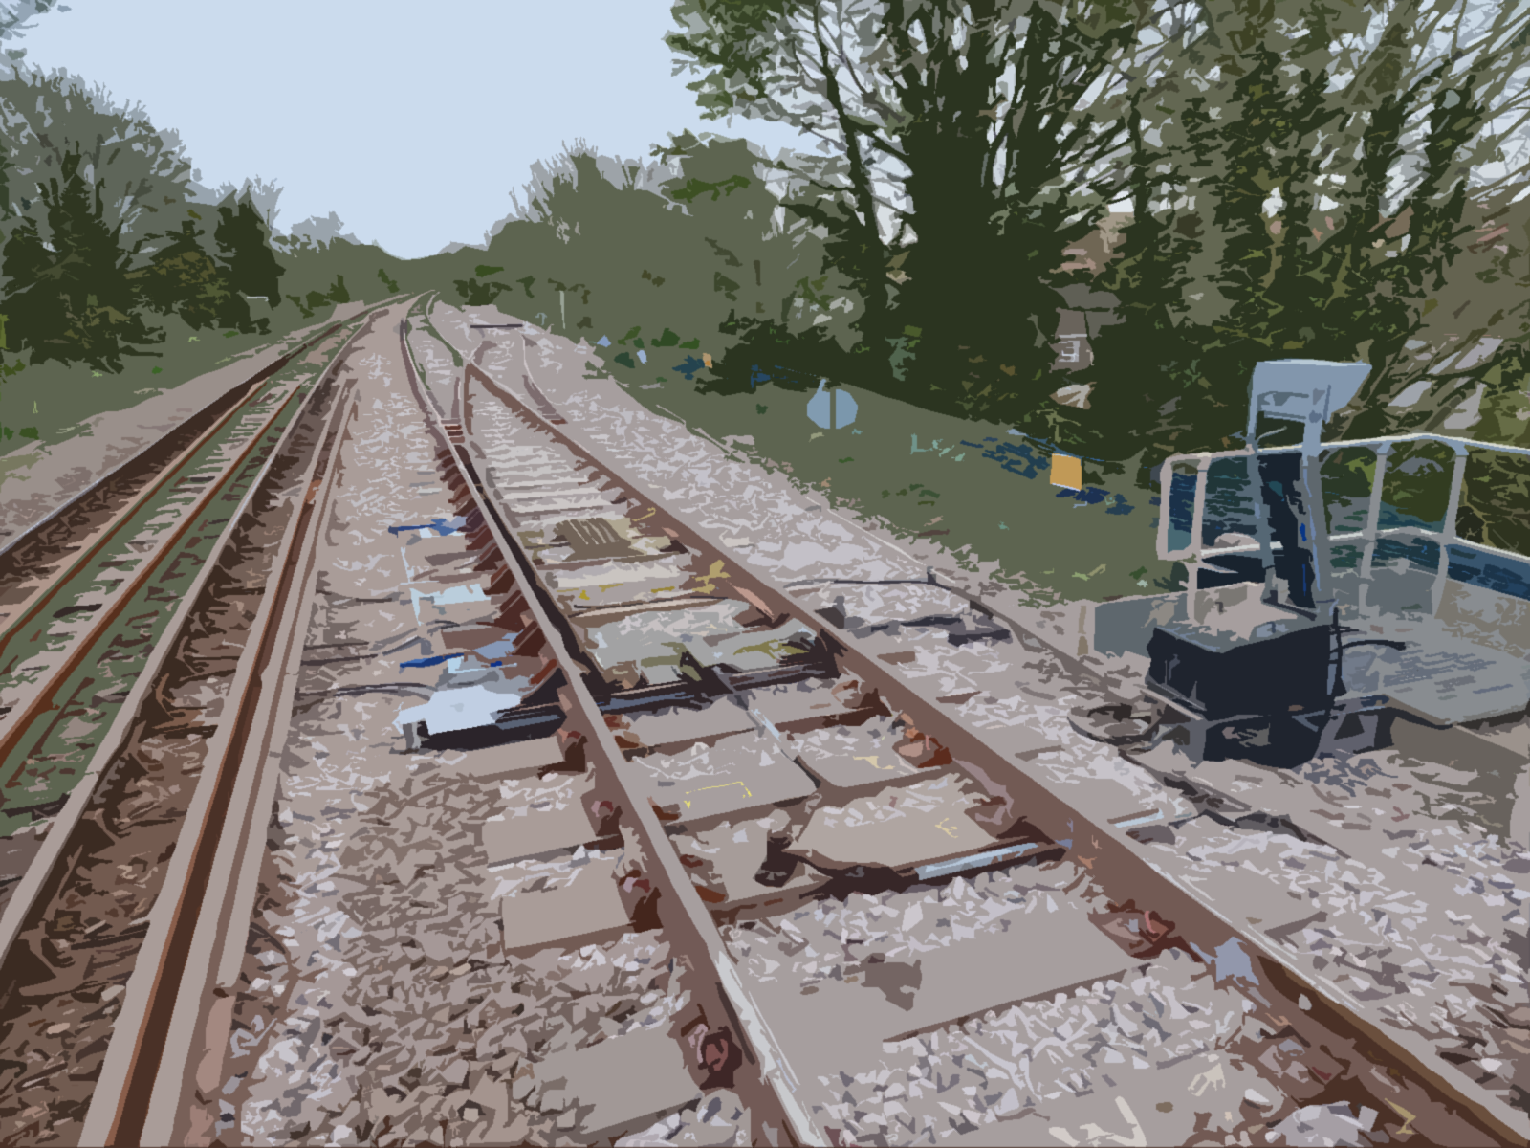
SAXMUNDHAM Case Study
Overview:
TES 2000 were awarded the Saxmundham project as Principal contractor by Network Rail works delivery Anglia.
The work included the replacement of existing 95lb B switch, B trap and sidings as per below:
- 113lb CV Turnout
- 113lb BV Trap
- Renewal of sidings plain line with 113lb panels
- 50mm skim dig
- Replacement of 95lb AS1 chairs with M-AS1P baseplates
- Replacement of 5 x hardwood sleepers
- Installing 2 x twist rails and 4 x 113lb rails off the fronts
- Replacement of groundframe components- Lock, channel rodding, stools, cranks etc
- The installation of a new back drive
- Tamping
- 18 x cold welds, 2 x stress welds
- 1 x stress off the rear of the crossing
- Installation of geometry and datum plates

Planning change
TES 2000 staff visited Trackworks in Doncaster to check over the new layout. The layout was due to be delivered to a compound close to Saxmundham on tilting lorries but with less than 2 weeks before the work was due to start, TES had to re plan the whole job over both weekends because of access point issues.
The panels that were due to be unloaded at Saxmundham would now be getting delivered to Whitemoor Depot and certain panels would be loaded on to the train. Due to the CV and BV switch panels having bearers over the size of 2600mm, the decision was made to replace the longer bearers on the panel with slave timbers at 2600mm, this meant that both panels could be safely loaded on to the salmon which would speed up works the other end.
All documentation needed to be re written for weekend 3 in line with the new plan and various de confliction meetings took place to ensure both TES 2000 and SRSA’s plan would work.
It was vitally important to get the plan sorted in time for weekend 3, when we would also undergo our annual PCL audit on site.
We are happy to say that the PCL audit went very well as planned and we passed with no advisories.

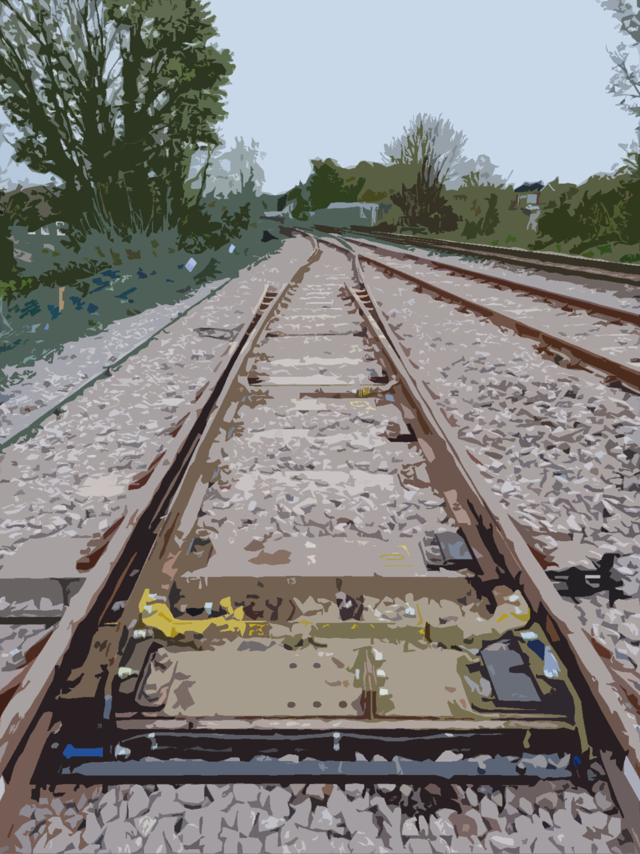
Logistics
On weekend 3 and 4 TES 2000 and SRSA shared the same possession, same train and same access point for RRV’s.
The RRV access point (Beversham) is 4 miles away from Saxmundham station and because the TES worksite was further towards country, it was agreed that our RRV’s would get on first both weekends. Over both weekends careful planning was needed around RRV’s and Engineering train movements.

Weekend 3
On weekend 3, the engineering train was shared by both TES and SRSA. This train had materials on for both jobs. The train initially stopped at the TES worksite and the RRV’s from Story Plant were able to unload all our panels (6) plus loose timbers, ironwork and smalls. Once unloaded the train then moved down into the SRSA worksite. At all times, site managers from both TES and SRSA were in contact with one and other.
Once our materials were unloaded the Story Plant RRV’s then tandem lifted the panels on to the end of the siding and stacked them. The loose panels were then rebuilt inline with the 1:50 drawings, these were then stacked in the sidings.
Our S&T sub-contractor Technotrack Engineering, began work on disconnecting all the POE equipment and took the release for the groundframe from the signaller. They then began the task of prepping the channel rodding, stools and rollers.
Our track team then replaced 5 x sleepers and installed 6 x rails, with 4 welds being dropped and 4 x temporary joints being formed and clamped with Robel10 clamps.
The worksite was then tidied at the end of weekend 3 and the RRV’s made their way back to the access point. A 50mph pre planned TSR was then erected and the track was handed back.

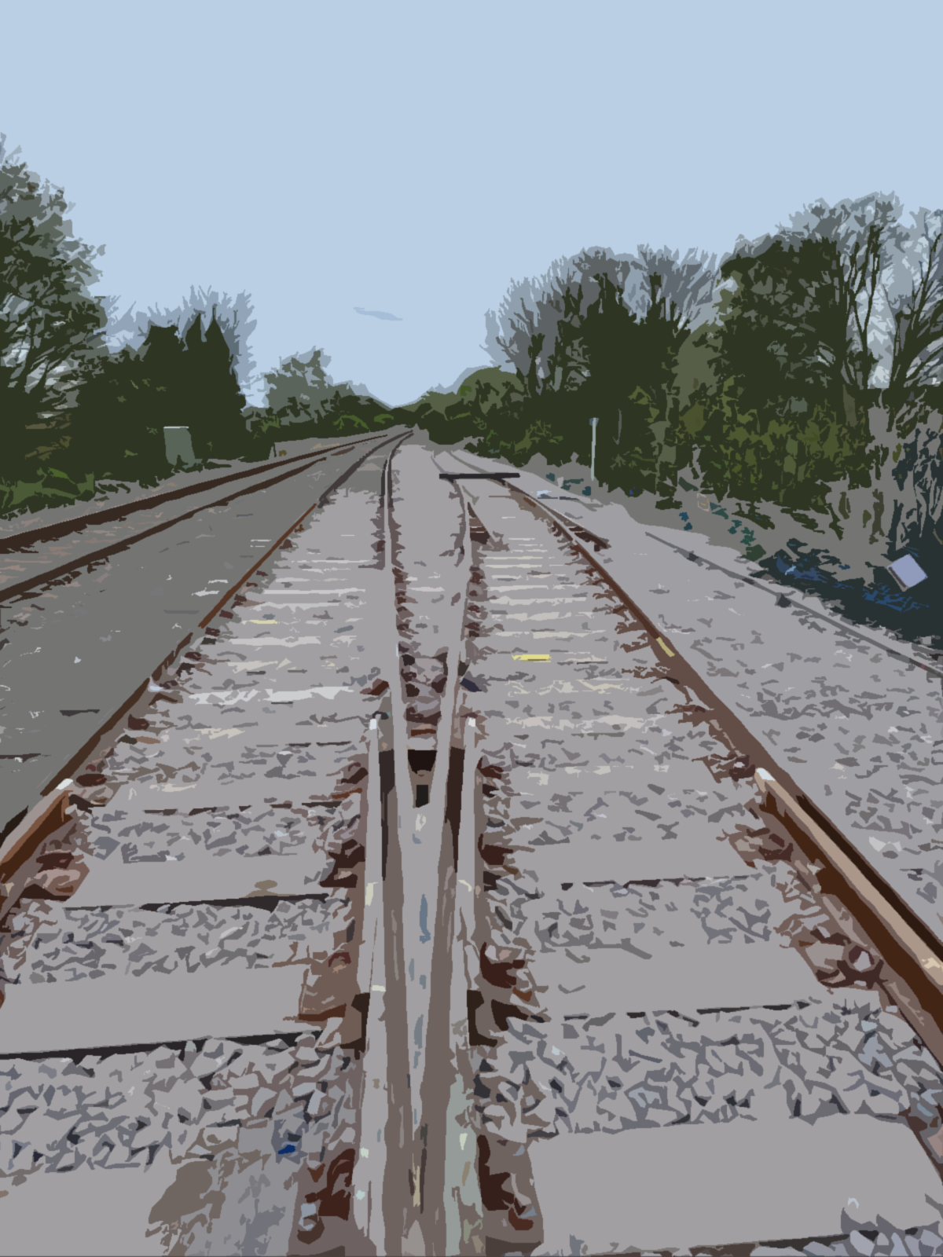
Weekend 4
When the possession was granted both the track and S&T teams got going with disconnecting the track circuits, existing track components and Points operating equipment. The RRV’S from Story Plant, again accessed at Beversham level crossing and made their way to site via send and receive.
The engineering train for both TES and SRSA was split so that each party had control of their own locos. Again, staying in contact via back to back radios throughout the weekend.
Once the RRV’s were on site at Saxmundham they then began loading all old components on to falcons.
The skim dig then commenced with the technical team on hand to check levels throughout the dig and Basestone stage. The new formation was then wacked 3 times to consolidate.
The technical team then set up the Trimble equipment, ready to land the first panel- 2A switch panel. The panel was landed within 2mm of design at the toes.
Each panel thereafter was landed and plated and clamped in readiness for welders, this included the Up Main panels, the 2B traps and the sidings panels.
The toe to nose was checked after the up main panels were in with only a 3mm deviance from design.
It was at this point when the timings needed to be correct: SRSA then began the tamp of the up main, finishing just short of the tie in location for both parties. TES then got the welders on to site with a focus being on dropping 14 x welds in time for the morning when SRSA would then stress up to the front of 2A toes.
Whilst SRSA were stressing up to the toes, TES then started top stoning the layout in readiness for the tamper to enter the worksite at 11:00 hours.
The engineering train was then reformed and was taken out of the worksite towards London.
SRSA worked quickly and finished the stressing prior to the tamper entering the TES worksite.
The TES technical team had the asbuilts prior to the tamper entering the worksite. They met with the tamper crew, input the figures and began the tamp of the S&C. This was followed by the tamp of the sidings.
The TES tamper was then handed over to SRSA so they could complete the final 50m of tamping up to the tie in point with TES. (London side of the underbridge)
The RRV’s then crossed over to the down road and made their way back to Beversham level crossing, passing through the SRSA worksite on the way back.
S&T teams worked tirelessly to get the new groundframe points equipment installed including, a new back drive, new rodding, stretcher bars, lock bars, cranks and cutting the new lock.
The track teams cleared site, snagged and carried on with ballast works until S&T were complete.
Track circuits, Interupters and points were all tested with documentation completed.
The site was then walked on all three roads and A-G, CRT’s and all other paperwork completed before the site was handed handed back, fit for traffic at the 55mph line speed.

